**WEB DESIGN**

**PROJECT REPORT**

|  |  |
| --- | --- |
| **PROJECT TEAM** | |
| **Student No.** | **Student Names** |
| **20146531** | **Eduarda Cavalcante** |
|  | **Kamila Ferreira** |
| [**20117817**](mailto:%78%32%301%317%381%37@%73tu%64%65%6e%74%2e%6ec%69%72%6c.%69%65) | **Thales de Hemeterio** |

**\*\* Debora Mendes Photography \*\***

**\*\* Insert deployed website URL Here \*\***

**Overview**

The main propose of this project is to compile the portfolio of a great photographer in a webpage and make it easier to be found by the regular and, also, by the potential customers.

We were hired by Debora Mendes to create a page and show to the public her job and her history.

As we told her, good professionals can organise a portfolio, talk about his/her projects and open a direct line with the customers through a URL.

Furthermore, it is very clear that webpage is vital for any business in our days, it is almost the visit card. If you need to find a service or a product, you will use the main web searchers (like Google) and would click on the results to know better that one which call your attention.

Therefore, our mission is to release an incredible gallery with the best photos of Debora Mendes in a very intuitive webpage.

**Section 1: Design**

## Research / Investigation

**Competitor #01: Hannah Jayne Photography**

* How the business looks like: The webpage is simple and full of emotion. They chose three beautiful photos from the professional and put them on the homepage as a presentation.
* Likes: The font-family and the layout are very simple and easy to navigate.
* Dislikes: The homepage mix with the “About me” in the end of the page.
* Ideas that we have: To create our homepage with a few information and with beautiful images.

**Competitor #02: Nicola Webster Photography**

* How the business looks like: The webpage is full of information and not so intuitive, however, it seams to be a great professional. Even because, she has many awards.
* Likes: The professional used the photographer own picture in the section “About me” and it makes the business more personal.
* Dislikes: The mix of many photos on the homepage made the site a little bit polluted.
* Ideas that we have: To include the photographer’s own picture in the “About me” section.

**Competitor #03: Frank Gavin Photography**

* How the business looks like: On the homepage we can see since when the professional is on the market and it probably makes the customer more comfortable. It shows experience from the photographer.
* Likes: The webpage seams to be very complete, with section to show the job and, also, to a blog, FAQ, and gift vouchers.
* Dislikes: The colours used by the web designers was very similar, which did not highlight the professional’s job.
* Ideas that we have: Include an option to gift voucher.

## Requirements & Technical Approach

** This section should outline what requirements that project might have and how you initially plan to approach project development, taking these requirements into consideration. You should also address other design aspects such as looking at suitable design hueristics/standards that you feel will contribute to your project. **

## Sitemap & Wireframe

** Include sitemap and wireframe for your website here, including brief explanations of each as needed, etc. **

This is the **Home Page**, by clicking on the menu available, it brings the users to the linked pages.

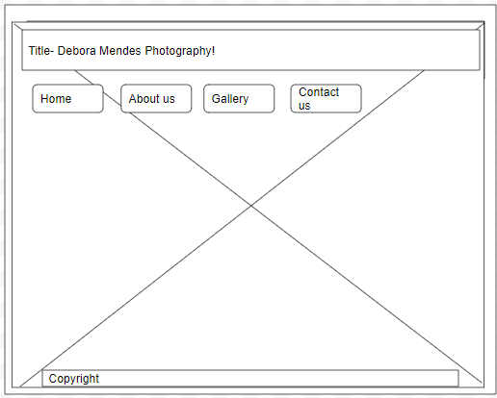

This is the **About us** page. It is a brief history about Debora Mendes.

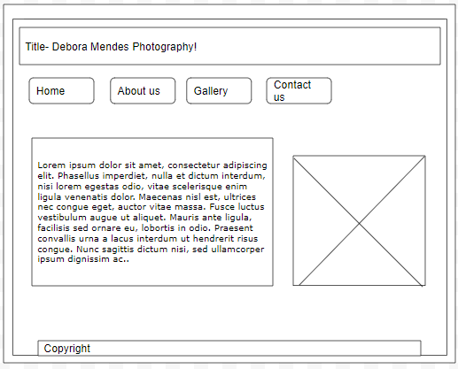

This is the **Contact us** page, where the user can request more information

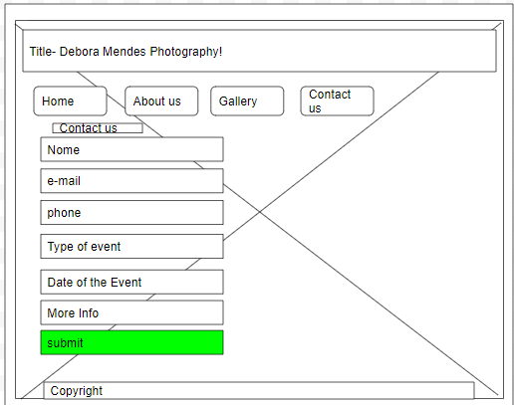

**Section 2: Development**

** This section should outline how you went about developing your webpage, i.e. HTML, CSS, JavaScript. This should include information on requirements and standards implementation, code development and technical details, such as errors or development issues and how you fixed these.

**Please note:** Make sure to include an explanation in this report (**as well as** comments in the HTML files) of any & all code that was taken from the web, or you will **not** receive marks for this third-party code. **

**Validation & Errors**

** This section should look at validation of the website (HTML & CSS), were you able to validate the website, were there any errors and if so, how did you go about fixing them.

**Please make sure to include a screenshot(s) of your validation reports here \*\***

**Section 3: Deployment**

** This section should include information on your choice of deployment, as well as your websites URL and a screenshot of the live site **

**Section 4: User Testing**

** This section should include information on any user testing carried out on your website, i.e. how many people you tested it on, what tasks you asked them to preform, the results of testing, if you implemented any user suggestions, etc. **

**Section 5: Project Team**

The team split the tasks equally and had four meetings during the development period to keep the same idea for the project and, also, to share the results.

Each member of the group made one index.html file and the following tasks:

* Eduarda: portfolio.html file, research, development and validation.
* Kamila: aboutus.html file, wireframe, user testing, development and validation.
* Thales: contactus.html file, deployment, development and validation.

We worked as a team and we didn’t have any issues.

**Section 6: Conclusion**

Due to the lack of time and enough knowledge to develop a complete webpage, the project was very challenger for us, however, we are satisfied with the result. We had planned to develop a simple and easy handling page, and, in our opinion, the goal was achieved.

We might had changed the JavaScript implementations and would improve it more, although we’ve did our best until now.

**Section 7: References / Appendix**

** Make sure to include any references to third-party resources / information / code used here.

**Make sure to reference correctly as needed, i.e. Harvard Referencing, or marks will be deducted**. **

**NOTE:** Please see NCI Library website for guides on Harvard Referencing if needed